1.WAP to make calculator using switch statements.
Code:
import java.util.Scanner;

public class calculator {
public static void main(String[] args) {
Scanner scanner = new Scanner(System.in);

System.out.print("Enter first number: ");
double num1 = scanner.nextDouble();

System.out.print("Enter second number: ");
double num2 = scanner.nextDouble();

System.out.print("Enter an operator (+, -, *, /): ");
char operator = scanner.next().charAt(0);

double result;

switch (operator) {
case '+':
result = num1 + num2;
System.out.println("Result: " + num1 + " + " + num2 + " = " + result);
break;

case '-':
result = num1 - num2;
System.out.println("Result: " + num1 + " - " + num2 + " = " + result);
break;

case '*':
result = num1 * num2;
System.out.println("Result: " + num1 + " * " + num2 + " = " + result);
break;

case '/':
if (num2 != 0) {
result = num1 / num2;
System.out.println("Result: " + num1 + " / " + num2 + " = " + result);
} else {
System.out.println("Error: Cannot divide by zero.");
}
break;

default:
System.out.println("Error: Invalid operator entered.");
}

scanner.close();
}
}

Output:
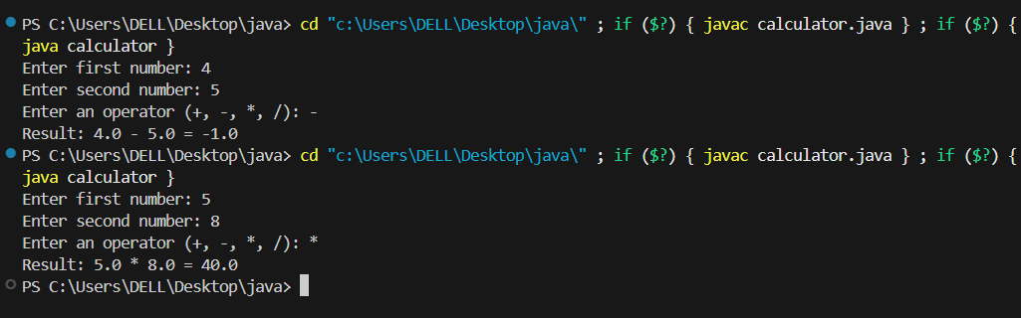
2.Write a Java program to demonstrate the concept of Method Overriding using inheritance
and runtime polymorphism in Java.
Code:
// Parent class
class Bank {

double getInterestRate() {
return 5.0; // Default interest rate
}
}

// Child class 1
class SBI extends Bank {

// Overriding method
double getInterestRate() {
return 7.5;
}
}

// Child class 2
class HDFC extends Bank {

// Overriding method
double getInterestRate() {
return 8.2;
}
}

// Main class
public class method_overriding2 {

public static void main(String[] args) {

Bank b1 = new SBI(); // Runtime Polymorphism
Bank b2 = new HDFC();

System.out.println("SBI Interest Rate: " + b1.getInterestRate() + "%");
System.out.println("HDFC Interest Rate: " + b2.getInterestRate() + "%");
}
}

Output:
